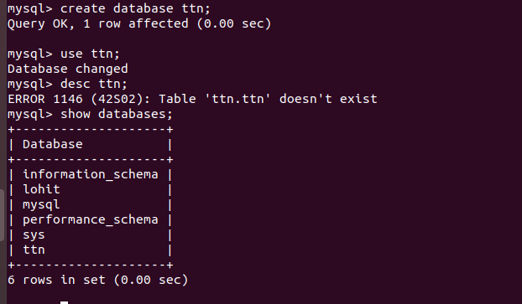
Introduction to Database by Lohit Ahooja
1. used create database database_name; command to create the database and then used use database_name; to use it and then used show databases; command to find the number of database in my computer.

2. Drawn this schema on www.draw.io and here fk refers to the foreign key and pk means primary key
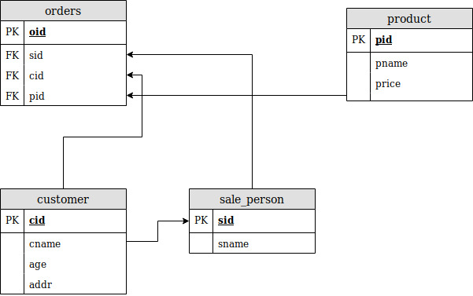

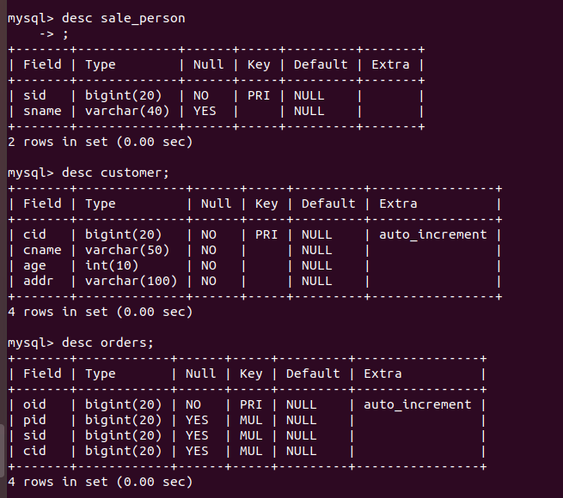

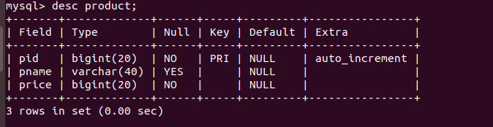

3.used create table table_name(column_name column_type,……….);

4. used insert into table_name(column_name) values (values……….); or we don’t need to specify the column name in case of ordering is values input is same as schema columns ordering

Insertion in customer table
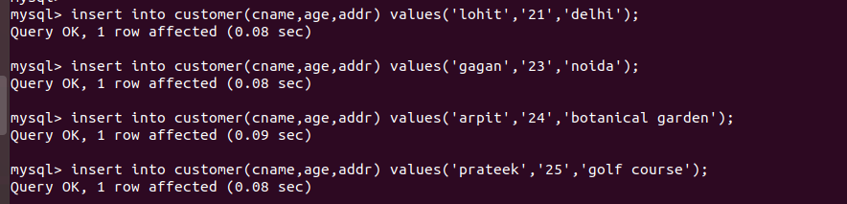
insertion in product table
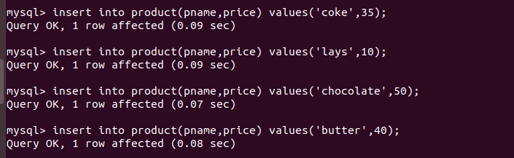
insertion in sale_person table

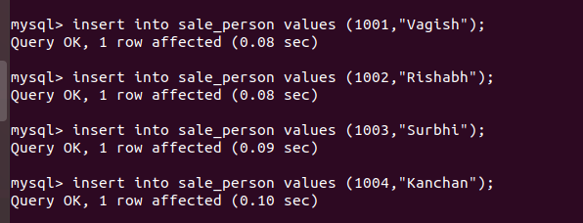

insertion in orders table

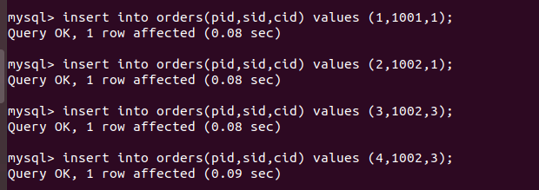

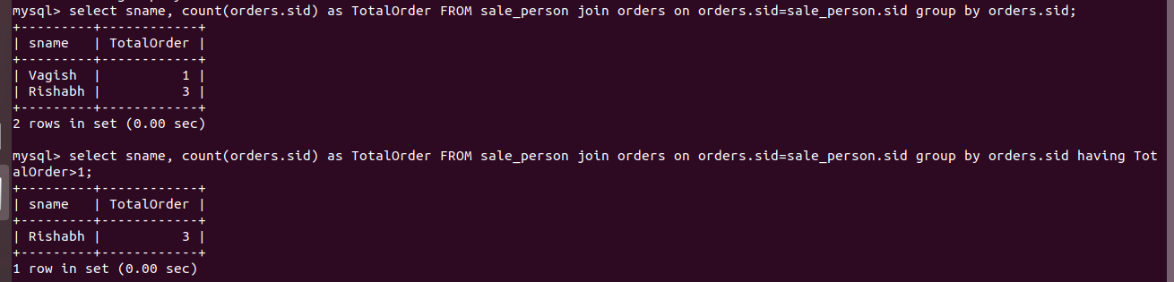
5. I have joined the table using the sid because it was the primary key of sale_person and foreign key to orders and then grouped by sid then counted it using count() function.

6.used left join in between table sale_person and orders on sid of orders and sale_person
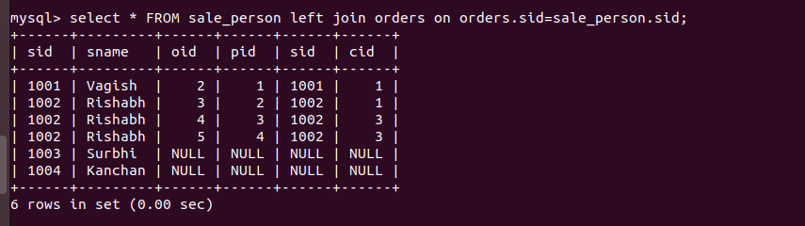

8. used command alter table table_name add index index_name(primary key) to create the index on primary key and used show index from table_name to see the index.

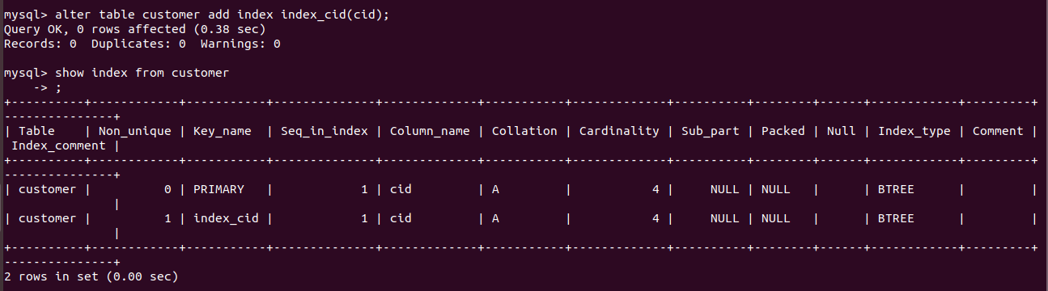

9. matched the sid of orders with sale_person to find the sname and used cid to find the customer name from customer and oid is fetched from the table orders.

